INTRODUCTION: This activity will help you to learn the vocabulary describing the human body. This vocabulary consists of directional terms, body sections and planes and body cavities. All the terms are used relative to the anatomical position which provides us with reference for describing the body. This means the person is standing and facing the observer. The arms are at the sides of the body with the palms facing forward.

PURPOSE: To learn and understand the terminology used to describe the organization of the human body.

MATERIALS: gummy bears, razor or knife, note cards for labeling, anatomical structures

PROCEDURE:

PART I: Directional terms. You have already used the terms below in your Anatomical Drawings you completed. There are six pairs most commonly used, each term in a pair is the opposite.

Superior-Inferior Superficial-Deep Medial-Lateral
Anterior-Posterior Proximal-Distal Right-Left
(Ventral-Dorsal)

Also, the following terms are used to define the location of specific parts of the body in relation to each other.

Bilateral-Ipsilateral-Contralateral
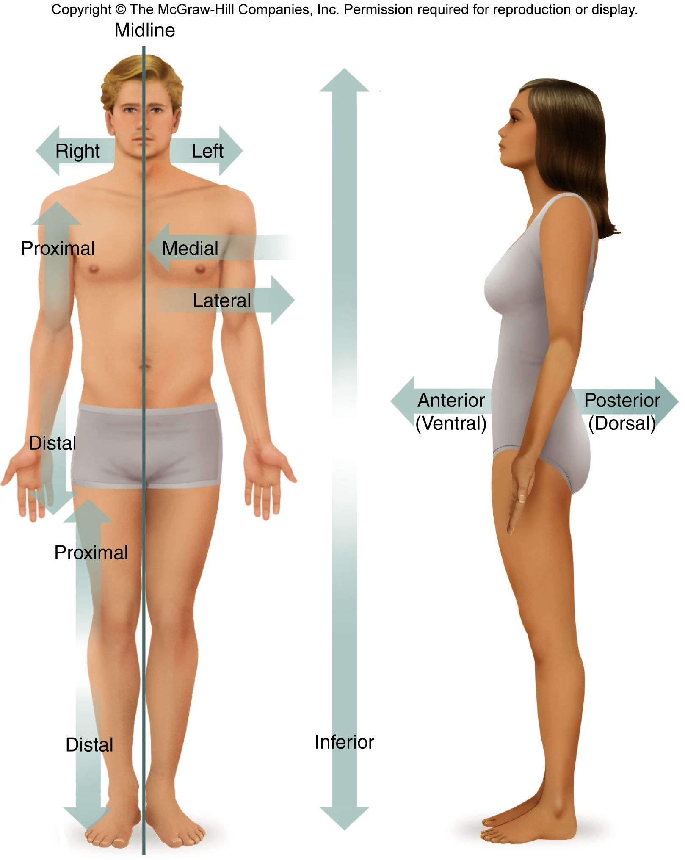

- Write a statement for each of the six pairs of directional terms. The statements should show the relationship of each pair.
Example:
“ The wrist is distal to the elbow, but the shoulder is proximal to the elbow.”
- On one side of five note notecards list two body structures. Have your partner write a sentence for each notecard using the correct directional term or terms on his/her lab paper. (Your partner should do the same for you, Each of you should staple the notecards to your lab and write sentences on your lab paper).

Example: Note card 1 has the terms heart and kidney. Your partner could write: “The kidney is inferior to the heart while the heart is superior to the kidney”.

PART II: Body sections and planes. The word anatomy is derived from the Greek prefix “meaning to cut up”. The sections are planes produced in the body to reveal its internal anatomy. There are three main sections:

Median/Midsagittal Frontal or Coronal Transverse or Horizontal



Median or Midsagittal Plane

Frontal or Coronal Plane

Transverse or Horizontal Plane

- Take one gummy bear and a blade. Cut through the median/midsagittal plane of the bear. Draw a picture of the two parts of the gummy bear after it has been cut and label them Diagram A-Median/Midsagittal.
- Take a second gummy bear. Now make a cut through the frontal or coronal plane. Draw a diagram including the two parts of the gummy bear and label them Diagram B-Frontal/Coronal.
- Take a third gummy bear and cut a transverse or horizontal plane. Label these Diagram C-Transverse/Horizontal.
- Give a description of the cuts you made for each of the planes: median/midsagittal, frontal/coronal and transverse/horizontal under each diagram.

PART III: Body Cavities. There are two principle body regions and these are broken up into smaller cavities.
- Axial portion
  - Cranial cavity

Vertebral canal
  - Thoracic cavity
    - Right and left pleural cavities
    - Pericardial cavity
- Abdominopelvic cavity
  - Abdominal cavity
  - Pelvic cavity
2.) Appendicular portion
- Limbs

- Copy the diagrams below and label each using the terms above. You should also include the diaphragm and the mediastinum.
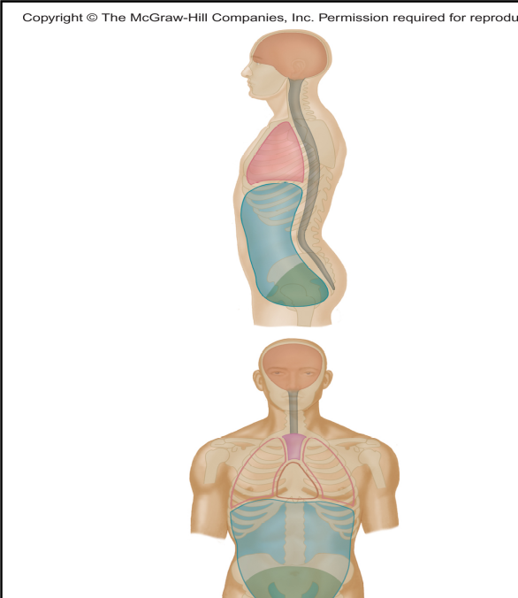

- Write the names of each structure below and identify which principle body cavity each would be found in and which sub cavity each would be found in.
Example: trachea=axial portion/thoracic cavity
Brain stomach
Lungs liver
Bladder spinal cord
Heart ovary
Uterus esophagus
Small intestines pancreas

- With your partner, write the name of each cavity on a note card and stick the card in the appropriate region on one of you. Show your teacher when you have done completed this so your group can be checked for the correct placement.

PART IV: Practice

- Copy each of the following statements on your own paper and fill in the appropriate word choice.
( superior or inferior)
- Abdomen________________vs. pectoral region____________________
- Oral region______________vs. nose________________________________
- Cervical region__________vs. tail bone___________________________
( anterior/ventral or posterior/dorsal)
- Nose_______________vs. ear___________________
- Knuckles __________vs. palm_________________
- Heel________________vs. toes _________________
(medial or lateral)
- Radius bone_________________vs. ulna bone___________
- Middle toe___________________vs. big toe_______________
- Orbital region_______________vs. ear__________________
(proximal or distal)
- Fingers___________________vs. carpal region_____________
- Upper arm_______________vs. clavicle____________________
- Lower leg________________vs. thigh______________________

PART V:
Write a summary conclusion about the organization of the human body and anatomical terminology. Describe what you learned and how these terms will be important in your study of anatomy and physiology.

