Brain and Spinal Cord Notes

Meninges
__________________________- membranes located between bone and soft tissues of the nervous system
3 Types of Meninges:
_____________________ = outmost layer, blood vessels, nerves
______________________ = no blood vessels, located between
_______________________ = contains many nerves and blood vessels to nourish cells of brain and spinal cord
*Cerebrospinal fluid =
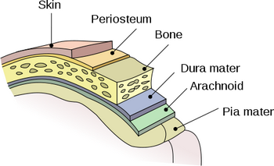
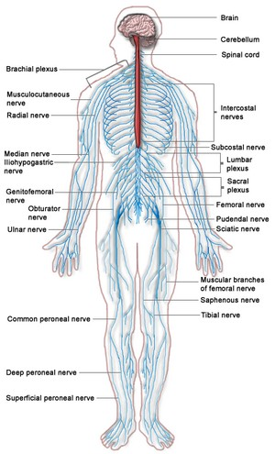

9.12 Spinal Cord
- _______________ _________________, passes from brain down through the vertebral canal
- has ________ segments, each with a pair of spinal nerves
___________________ enlargement = supplies nerves to upper limbs (neck)
____________________ enlargement = supplies nerves to the lower limbs (lower back)
FUNCTION:
_____________________ tracts = carry sensory info to the brain
______________________ tracts = carry motor impulses from the brain to the muscles
Spinal reflexes – reflex arcs pass through the _______________ __________
9.13 Brain
Three Major Parts:
___________________ – largest, sensory and motor functions, higher mental function (memory, reasoning)
____________________ – coordinate voluntary muscles
_________________ ____________ – regulate visceral functions

DESCRIBE THE FUNCTIONS:
1. Cerebral Hemispheres

2. Corpus Callosum

3. Convolutions / Sulcus / Gyrus

4. Transverse / Lateral / Longitudinal Fissures

