Circulatory System Study Guide
1. Calculate the cardiac output for a heart that has a 60 ml per beat stroke volume and a rate of 100 beats per minute.

2. Arteries carry blood ____________ from the heart.
Veins carry blood ____________ the heart.
3. Which of the following carries oxygenated blood? (you may circle more than one)
A) aorta
B) superior and inferior vena cavas
C) pulmonary artery
D) pulmonary vein

4) What do you call the loose, outer layer of the sac around the heart?
A) pericardium C) endocardium
B) epicardium D) myocardium

5) Which heart wall layer consists of cardiac muscle?
A) pericardium C) endocardium
B) epicardium D) myocardium

6) This layer is the innermost
A) pericardium C) endocardium
B) epicardium D) myocardium

7) Describe the size and location of the heart.

8) What divides the left and right side of the heart?
A) pericardium C) aorta
B) intraventricular septum D) myocardium

9) True or False: The right side of the heart is more muscular.
10) The _________________ lies directly in front of the heart.
A) sternum C) tibia
B) clavicle D) sacrum

11) What do the terms tachycardia and bradycardia mean? What is arrhythmia?

8. Label the P-Wave, the QRS complex and a T wave on the ECG.
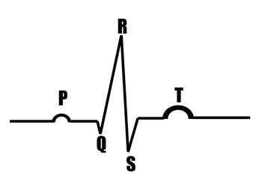

9. The ____________________ blood pressure is the maximum pressure achieved during contraction.
A) systolic C) cardiac
B) diastolic D) none of the above

10) What is the “normal” blood pressure for a human?

11) Name and give the function of all four valves of the heart.
Name of Valve | What it separates #1 | What it separates #2

12) Blood that moves from the heart to the lungs and back to the heart again is in the _____________________ circuit.
13) Blood moving throughout the body is in the ___________________ circuit.
6. Describe the function of the sinoatrial node and trace the path of a nerve (cardiac) impulse through the cardiac conduction system. (TEST BONUS)

12. Label all of the major vessels that attach to the heart.

13. Label a diagram of the heart and trace the flow of blood through the heart.

