Nervous System Cell Coloring
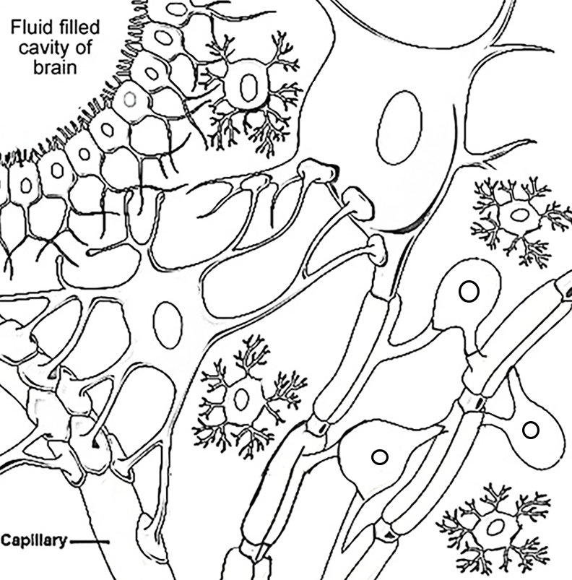
Oligodendrocytes (purple) Astrocyte (green)
Ependymal Cells (orange) Body of Neuron (blue)
Myelin sheaths (pink) Capillary (red)
Microglial cells (yellow) Nodes or Ranvier and the Axon (brown)
1) Oligodendrocytes ____________________________________________
2) Astrocytes _________________________________________________
3) Microglial cells _____________________________________________
4) Myelin sheaths ______________________________________________

5) Describe the path of a nerve impulse in a neuron starting with the dendrite.

