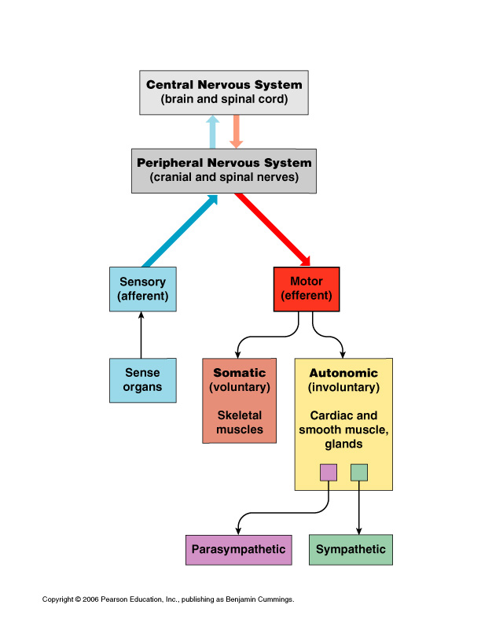
Nervous System Study Guide

1) Name and describe the 3 functions of the Nervous System.
2) Be able to fill in chart to the right
3) Name the 4 types of supporting cells in the CNS and describe them.
4) Name the 2 types of supporting cells in PNS and describe them.
5) Name 3 structural types of neurons.
6) Label Neuron (Figure 7.4 in text)
7) Define the following terms: synaptic cleft, neurotransmitter, synapse, irritability, and conductivity.
8) Draw a resting axon membrane including the ions and charge on either side of the membrane.
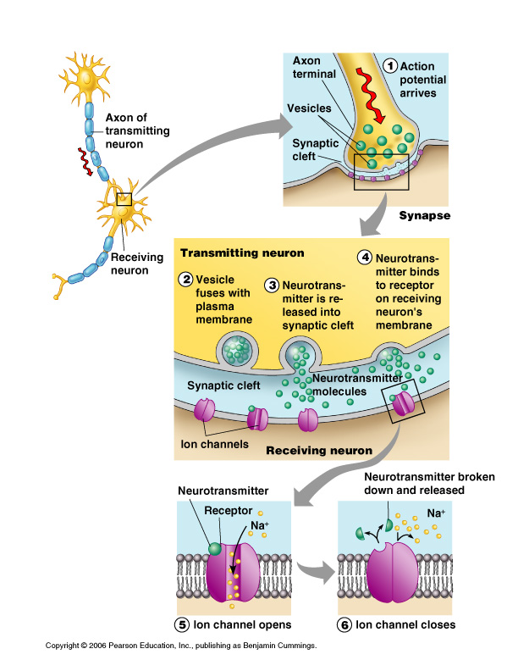
9) Describe what happens during the propagation of the action potential.
10) Label the types of supporting cells in the figure below:
