Superhero Blood Cell Project
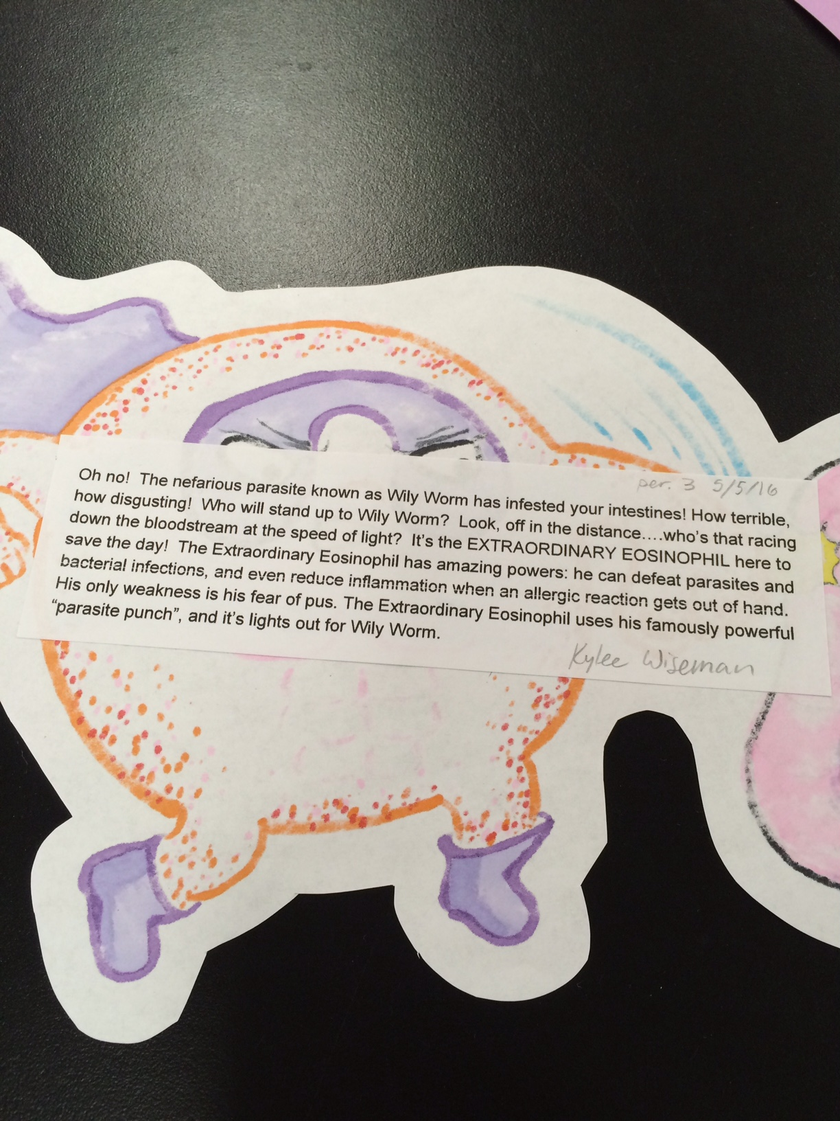
Choose a type of blood cell discussed in class and give it a superhero name based on its function in the human body. Then, write a description of your cell’s super powers and even a superhero weakness (even Superman has a weakness!). Include an illustration along with this description. See example below

