The Integumentary System Notes

Integumentary System Overview
1) Also known as _____________________________
2) Includes _________________ and ___________________

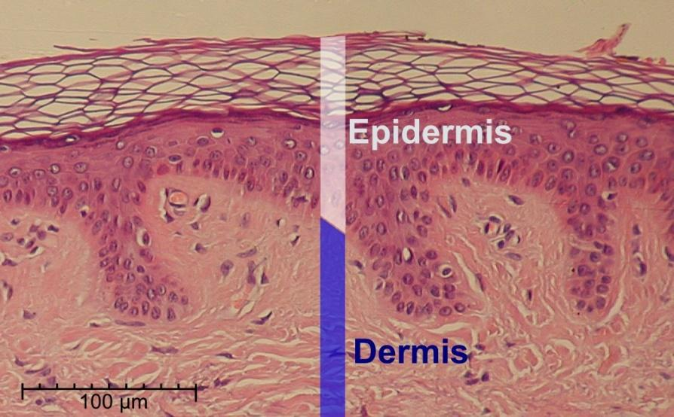
Distinct regions:
1)
2)
3)

Functions of the Integumentary System
1)
-
-
-
2)
3)
4)
5)

Epidermis

Location-

Types of cells in epidermis
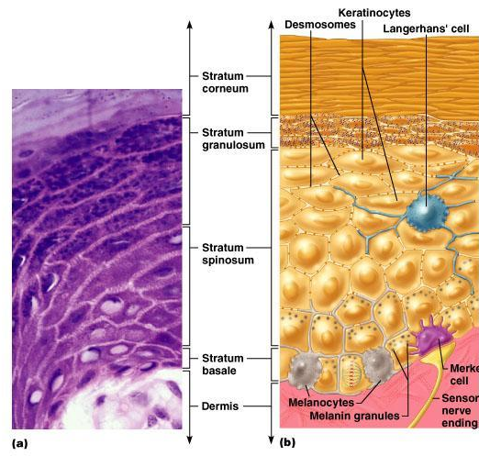
1)

2)

3)

4)

Layers of the epidermis (list and describe)
1)

2)

3)

4)

5)
Skin Color
3 pigments found in skin
1)
2)
3)
Which kind of cells produce pigment and what layer are they found in?

Dermis
Location-
Description-

Composition of the dermis
1)
2)
3)
4)

Function of the Dermis-

2 Layers of the Dermis

1)

2
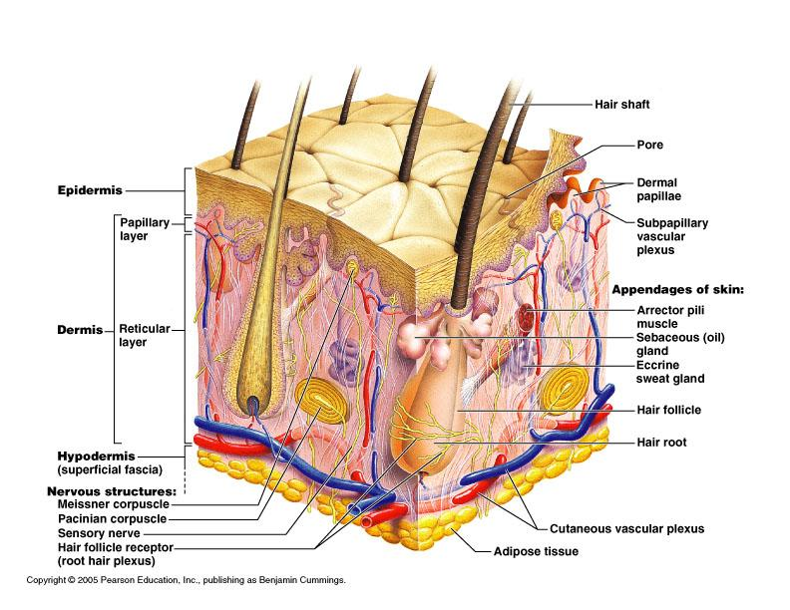

Fingerprints, Palmprints, and Footprints
-
-
-
-

Hypodermis
Location-
Also known as_______________________
Tissues found in the hypodermis
1)
2)
Skin Appendages
Derived from ____________________ and extend into _______________________.
Types
1)
2)
3)
4)

Nails
1)
2)
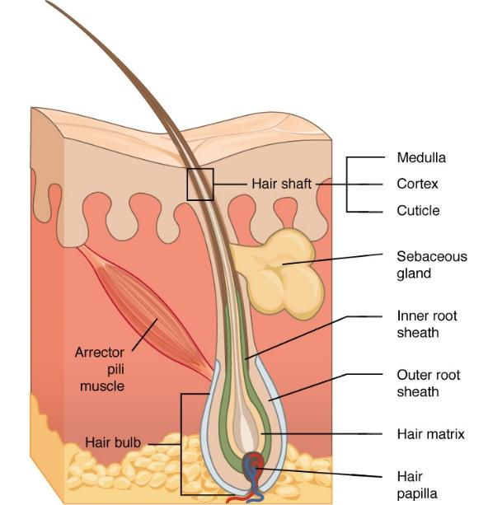
3)

Hair
Composition-
Parts-
3 Concentric layers (inner to outer)
1)
2)
3)
Location-
Function-
1)
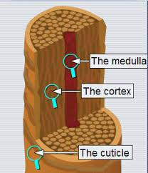
2)
3)
Arrector pilli-
Growth per week-

Sebaceous (Oil) Glands
1)
2)
3)

Sweat Glands
Location
Function

Types of Sweat Glands
- Eccrine

- Apocrine

Modified apocrine glands
- Ceruminus-

- Mammary-

