Tissue Notes

Tissue-

There are 4 major types of tissue:

1. Epithelial Tissue
General Characteristics:
-
-
-
-
-
-
-
-
There are _________ types of epithelial tissue we will learn.

Categorized based on the ___________________ of the cells and the ______________________ ___________ _________________.

Vocab you need to know to identify epithelial tissue:
Simple-
Stratified-
Squamous-
Cuboidal-
Columnar-

Pseudo-

SIMPLE EPITHELIUM

- SIMPLE SQUAMOUS

Description:

Function:

Location:

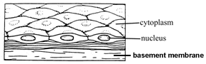

- SIMPLE CUBOIDAL –

Description:

Function:

Location:
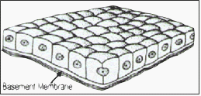

- SIMPLE COLUMNAR –
Description:

Function:

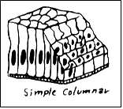
Location:

STRATIFIED EPITHELIUM

- STRATIFIED SQUAMOUS –
Description:

Function:

Location:

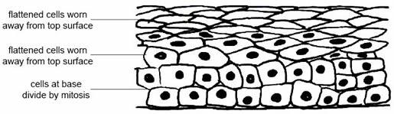

- STRATIFIED CUBOIDAL –
Description:

Function:

Location:

SPECIAL TYPES OF EPITHELIAL CELLS
- GLANDULAR EPITHELIUM –
Description:

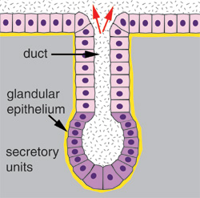
Function:

Location:

- PSEUDOSTRATIFIED COLUMNAR –
Description:

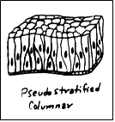
Function:

Location:

- TRANSITIONAL EPITHELIUM –

Description:
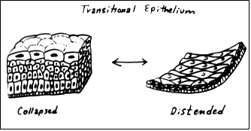
Function:

Location:

2. Connective Tissue
General Characteristics:
-
-
-
Functions:

Composition:
-
-
Three common types of cells in connective tissue:
1. Mast cells-
2. Macrophages-
3. Fibroblasts-
Main types of fibers:
1. collagenous fibers-
Example-

2. elastic fibers-
Example-
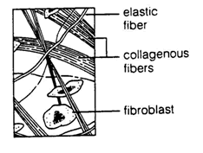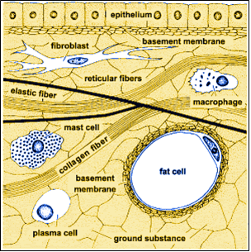
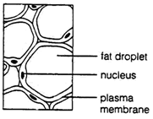
CATEGORIES OF CONNECTIVE TISSUE
1. Loose C.T. Areolar-

2. Adipose tissue - aka FAT,

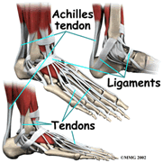
3. Fibrous C.T

4. Cartilage

Types of Cartilage
-Hyaline cartilage-

-Elastic cartilage ,

-Location:

-Fibrocartilage- .
Location:
5. Bone Tissue –

6. Blood Tissue-

3. Muscle Tissue
Function:
1. Skeletal -
2. Smooth -
3. Cardiac -
4. Nerve Tissue -
Function:
1. Neurons - transmit signals
2. Neuroglia - protection, support

